**9 SCIENCE CHEMISTRY ASSIGNMENT 2015**

History of the Atomic Model

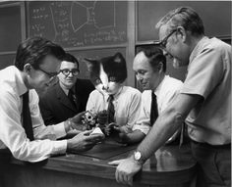

Name:__________________________ Due date:______________________

**Plagiarism**

🞟 This assignment is to be done individually, not with a partner.

🞟 You must write in your own words not copy sentences word for word from another student or

another source.

🞟 Plagiarising = instant zero on assignment and you will have to re-do it.

**Assessment policy**

Have sick note/legitimate reason from parent = new negotiated due date.

Assignment not submitted on due date and no sick note from parents = -20% mark

Assignment not submitted on new negotiated due date = -40% mark

+ Letter home to parents.

+ Must attend academic completion to complete assignment.

**OR**

Submit assignment to student services before academic completion date and academic completion not necessary.

Academic completion not attended = zero on assignment + Saturday detention.

If you know that you cannot submit your assignment on the due date, let your teacher know **BEFORE** the due date (email them if you are not in school) or just email them your assignment the night before.

**Assignment requirements**

You will hand in two things:

➀ This assignment booklet with the completed reference list and attached notes.

➁ Your timeline and report.

**Aim:** This assignment will allow you to see how the Atomic Theory started as a philosophical idea and through scientific experimentation over time, has been developed to include the current Electron Cloud Model. As scientists discovered more information they discarded parts of older theories to design an atomic model that provided a more accurate representation of the atom. It is important for scientists to challenge current theories and modify them as more knowledge becomes available.

Your research will provide you with a historical perspective of our knowledge of the atom’s structure as well as more detailed knowledge of a specific scientist involved in atomic model development.

**1. Create a timeline that shows the history of the atomic model.**

🞟 Use information from pages 8, 9 of text book.

🞟 Include the year, atomic model name, scientist who discovered or developed that specific atomic model.

🞟 Must be neatly hand drawn, in pencil, using a ruler, with an appropriate scale.

**2. Choose one of the following scientists to research.**

🞟 Ernest Rutherford 🞟 Neils Bohr 🞟 Sir James Chadwick

🞟 Sir Joseph J. Thomson 🞟 Philipp Lenard

1. Date of birth.
2. Place of birth.
3. Date of death.
4. Early life - information on their family life and where they grew up.
5. Where they completed their education.
6. A brief summary of what was going on in world history at the time they lived (e.g. World War 1).
7. The name of the atomic model they developed or discovered.
8. A description of the atomic model they developed or discovered.
9. A labeled hand drawing of the atomic model, use page 5 of activity book to help.
10. Awards or recognition they received (e.g. Nobel Prize, 1st person to…)
11. What else they did for a job or profession.
12. A description of some of their other contributions to science beside atomic theory.
13. A quote by your scientist or an interesting fact about your scientist.

**Reference list**

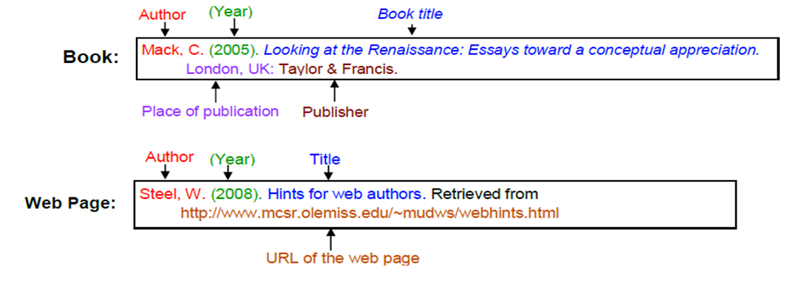Referenced using the style below (pg. 180 of your diary has more information).

_________________________________________________________________________________________________

_________________________________________________________________________________________________

_________________________________________________________________________________________________

_________________________________________________________________________________________________

_________________________________________________________________________________________________

_________________________________________________________________________________________________

_________________________________________________________________________________________________

_________________________________________________________________________________________________

_________________________________________________________________________________________________

_________________________________________________________________________________________________

_________________________________________________________________________________________________

_________________________________________________________________________________________________

_________________________________________________________________________________________________

_________________________________________________________________________________________________

_________________________________________________________________________________________________

_________________________________________________________________________________________________

_________________________________________________________________________________________________

_________________________________________________________________________________________________

_________________________________________________________________________________________________

_________________________________________________________________________________________________

_________________________________________________________________________________________________

**MARKING KEY**

|  |  |  |  |
| --- | --- | --- | --- |
| **Content** | **Description** | **Possible**  **mark** | **Your**  **mark** |
| Timeline | Appropriate title  Neat - used a pencil and ruler  Appropriate scale - stretches across full page Correct dates are in order  Correct information clearly stated for each date | 1  1  1  8 |  |
| Scientist  research | Date of birth  Place of birth  Date of death  Early life - minimum 2 sentences  Education – minimum 2 sentences  Summary of history at time - minimum 2 sentences  Description of specific atomic model - minimum 2 sentences  Atomic model diagram  - Neatly hand drawn in pencil  - Correctly labeled  - Takes up minimum 1/3of page  Awards or recognition  Other jobs or professions - minimum 2 sentences  Other contributions to science - minimum 2 sentences  Quote or interesting fact | 1  1  1  2  2  2  2  2  1  2  2  1 |  |
| Notes | Hand written notes are attached | 1 |  |
| Referencing | Minimum of 2 references  Variety of sources  Referenced in correct format – see student diary | 2 |  |
| Presentation | Cover page - full name, form, teacher, assignment title  Neat  The use of headings - clear separation of sections  Correct spelling, grammar, full sentences  Relevant images or pictures – referred to in the text | 2 |  |
| **Total mark** | | 35 |  |

Mark as percentage %

Teacher’s comments:

_________________________________________________________________________

_________________________________________________________________________

_________________________________________________________________________

_________________________________________________________________________